**Project Notes**

**Project:**Image Component Labelling  
**Author:**Chi Hon Law  
**Company:**Foothill College  
**Description:**  
An application of Stacks & Queues

**Things to do...**

* Compose the GUI and setup the event handlers (given-starter code)
* Enter Dimension: The image is always a square grid of pixels, min = 5x5 and max = 15x15 (default 10x10).
* The “Generate Image” push button activates a simple algorithm that populates the **pixel[][]** square array that represents the image with 1’s and 0’s for foreground and background, respectively – don’t forget the artificial wall around the image.
* The image components are labeled as discovered by the search algorithm. All pixels of the same component will have the same label and same random color.

**Snapshots**

Enter Dimension 10 and push “Generate Image”

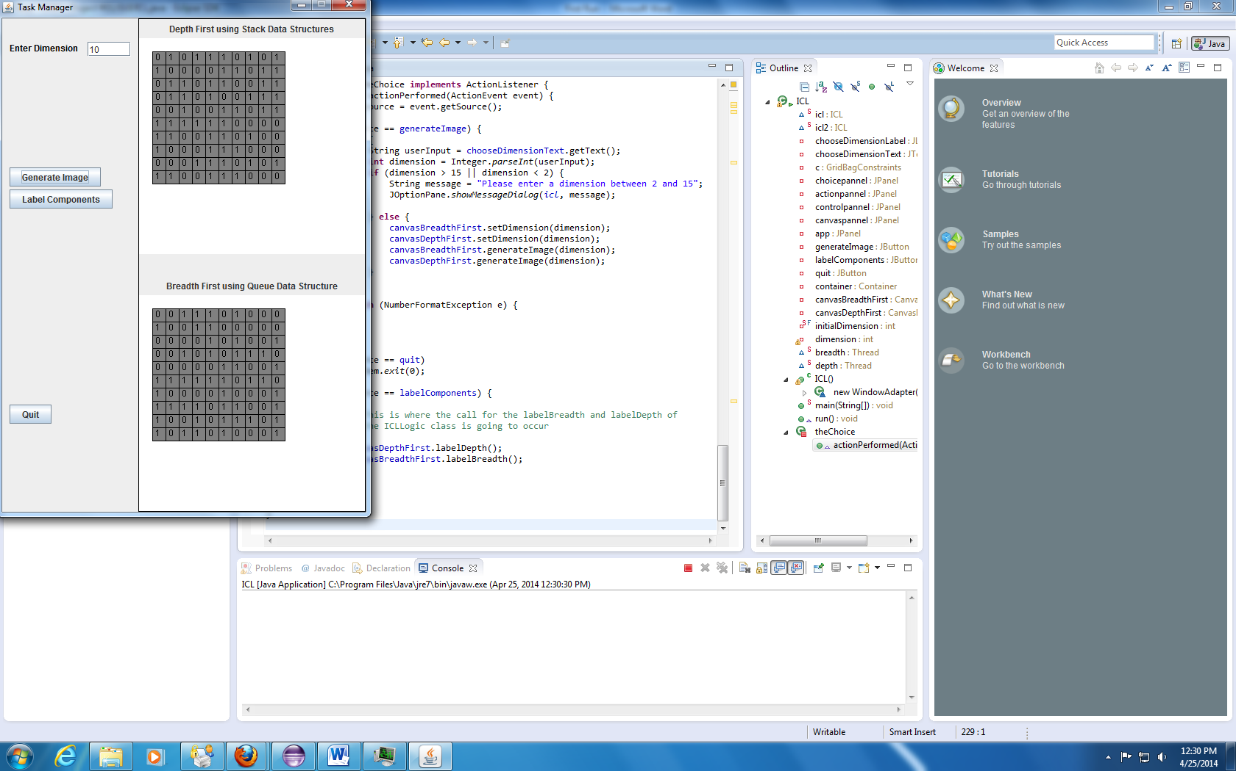

Depth First using Stack Data Structures (Prove that it is using Stack)

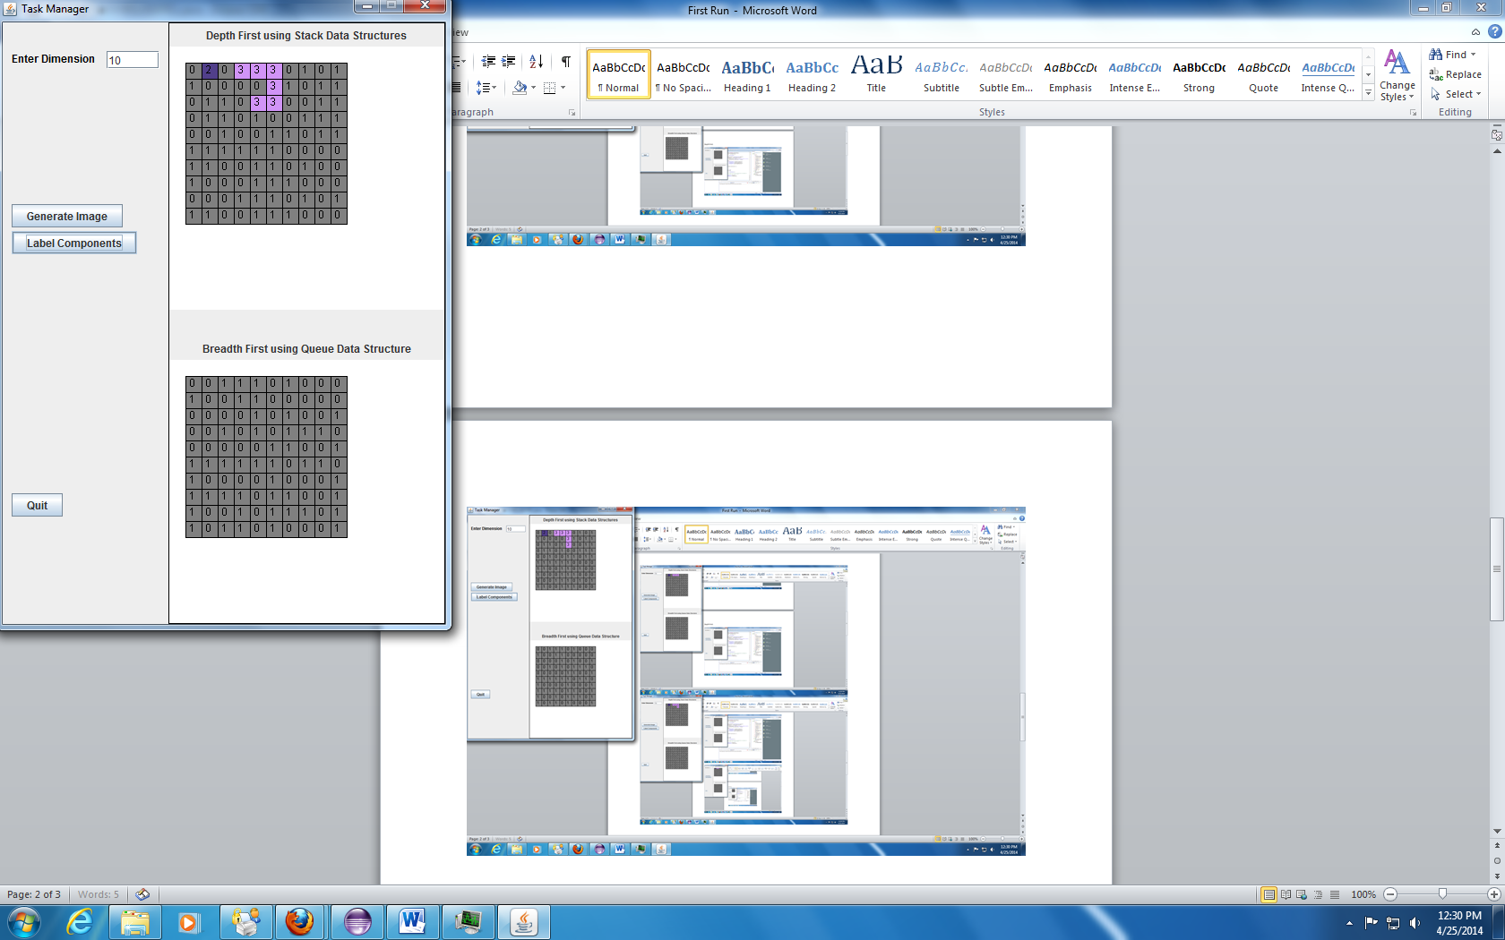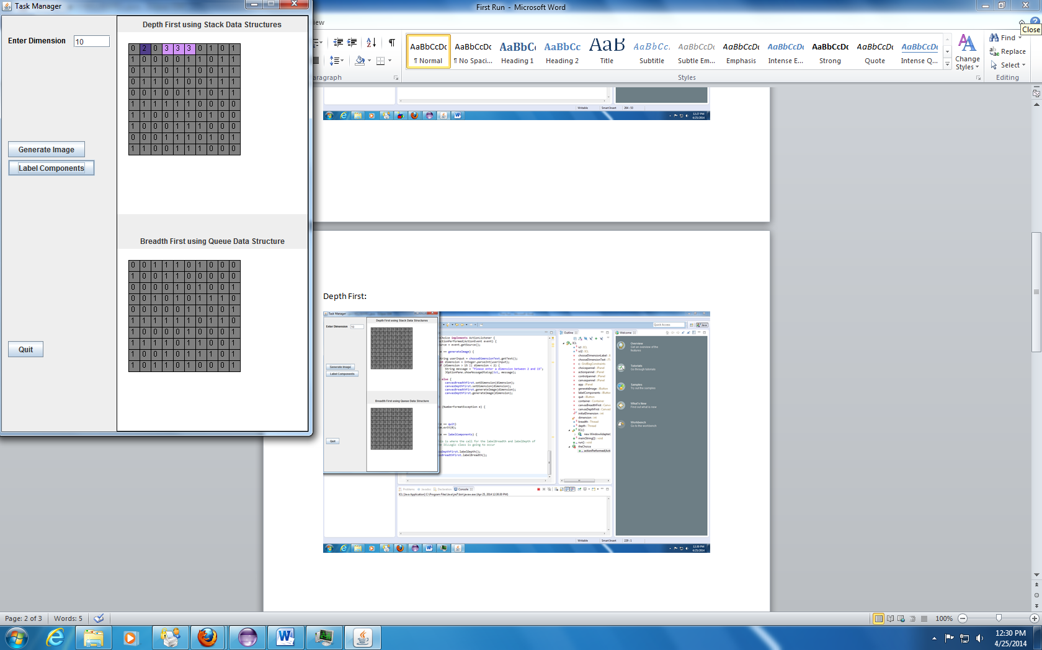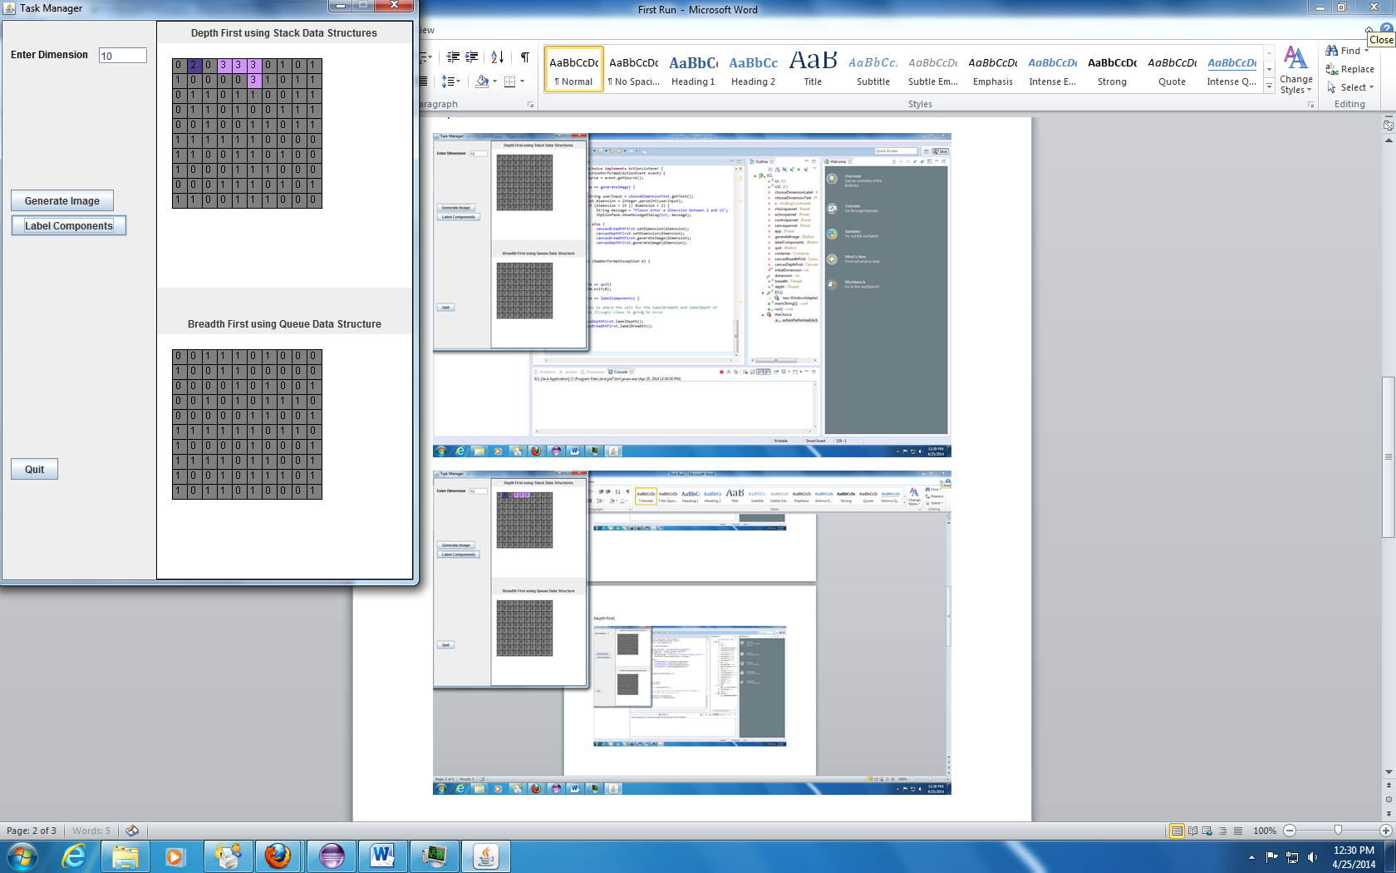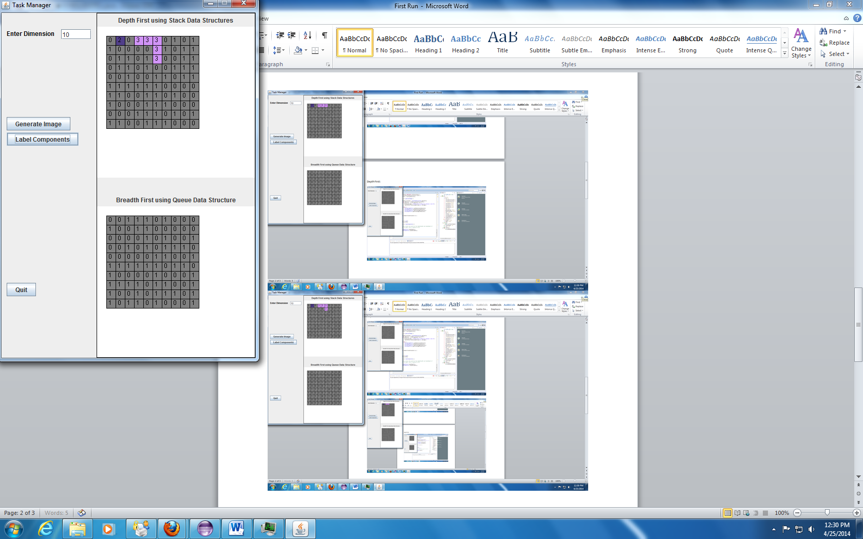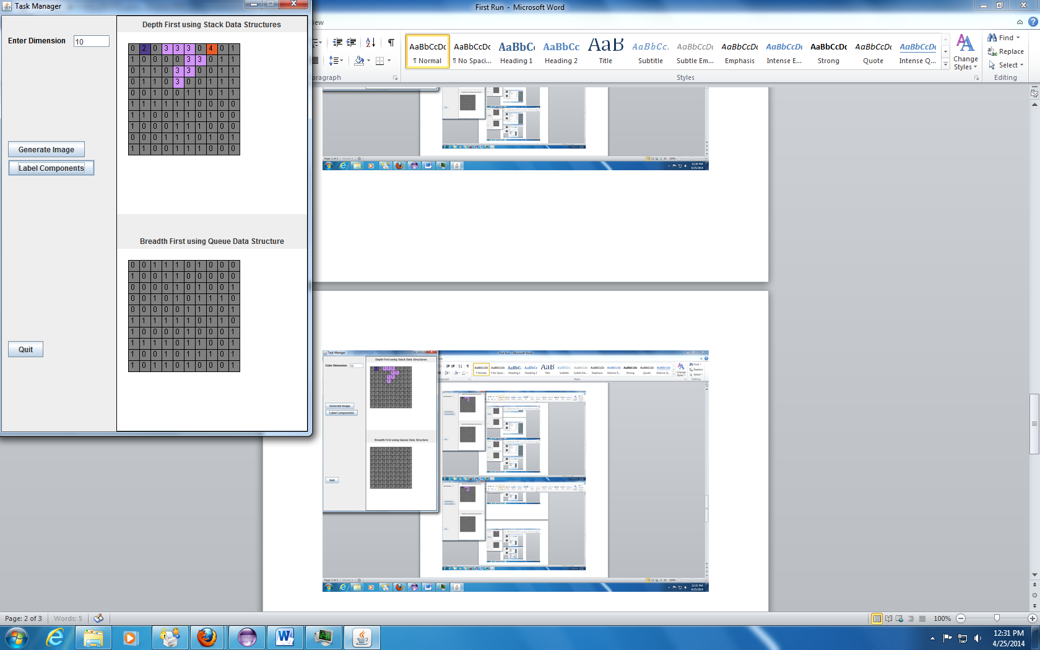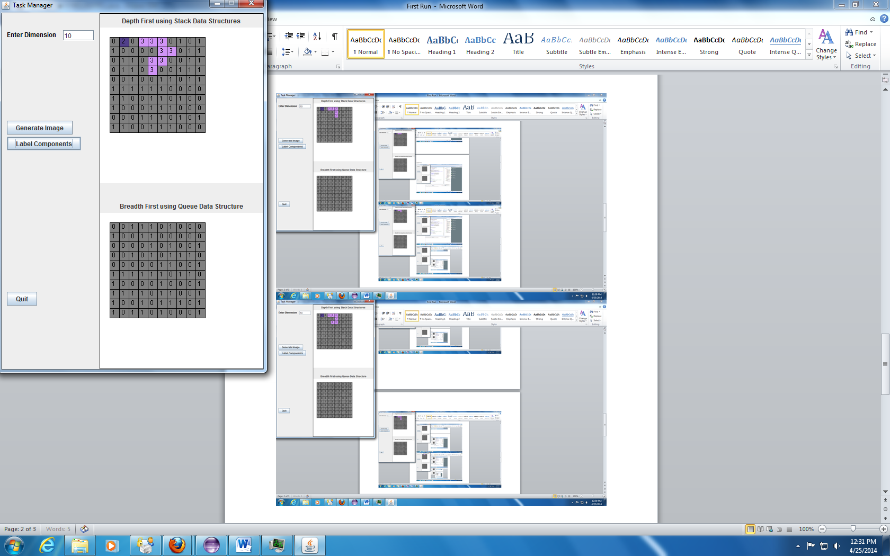

Breadth First using Queue Data Structure (Prove that it is using Queue)

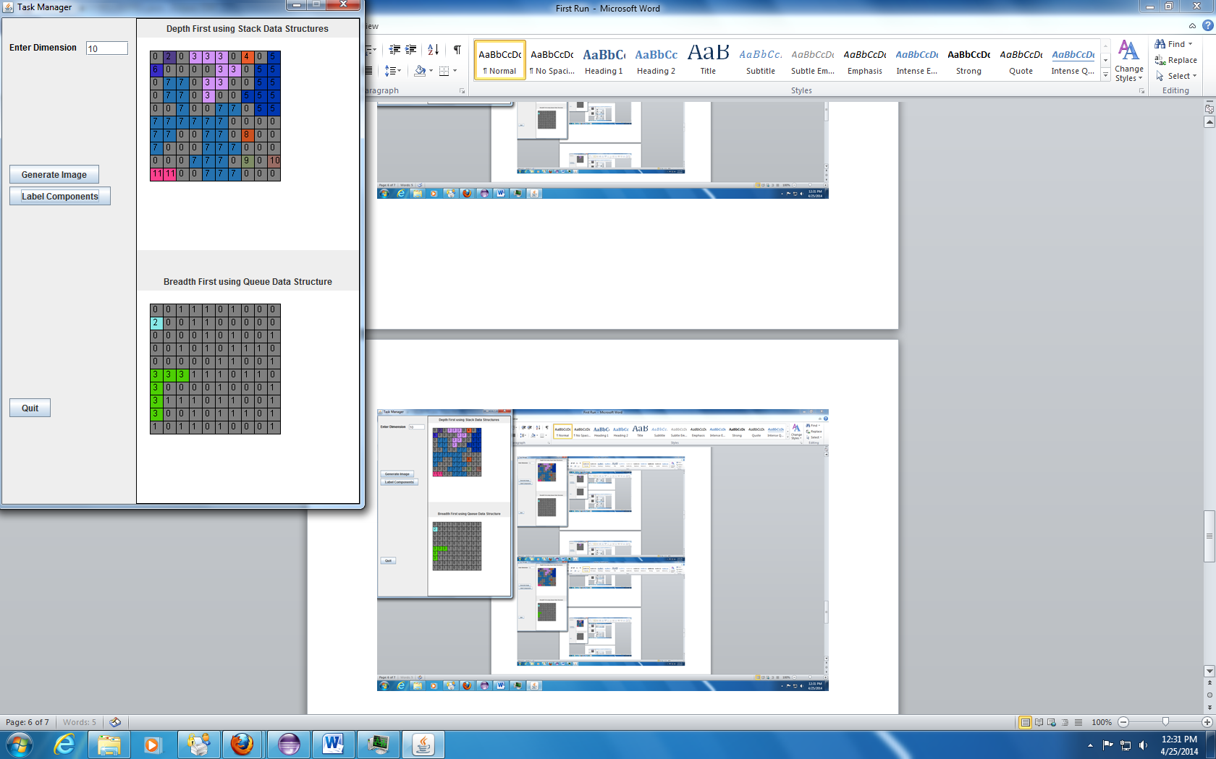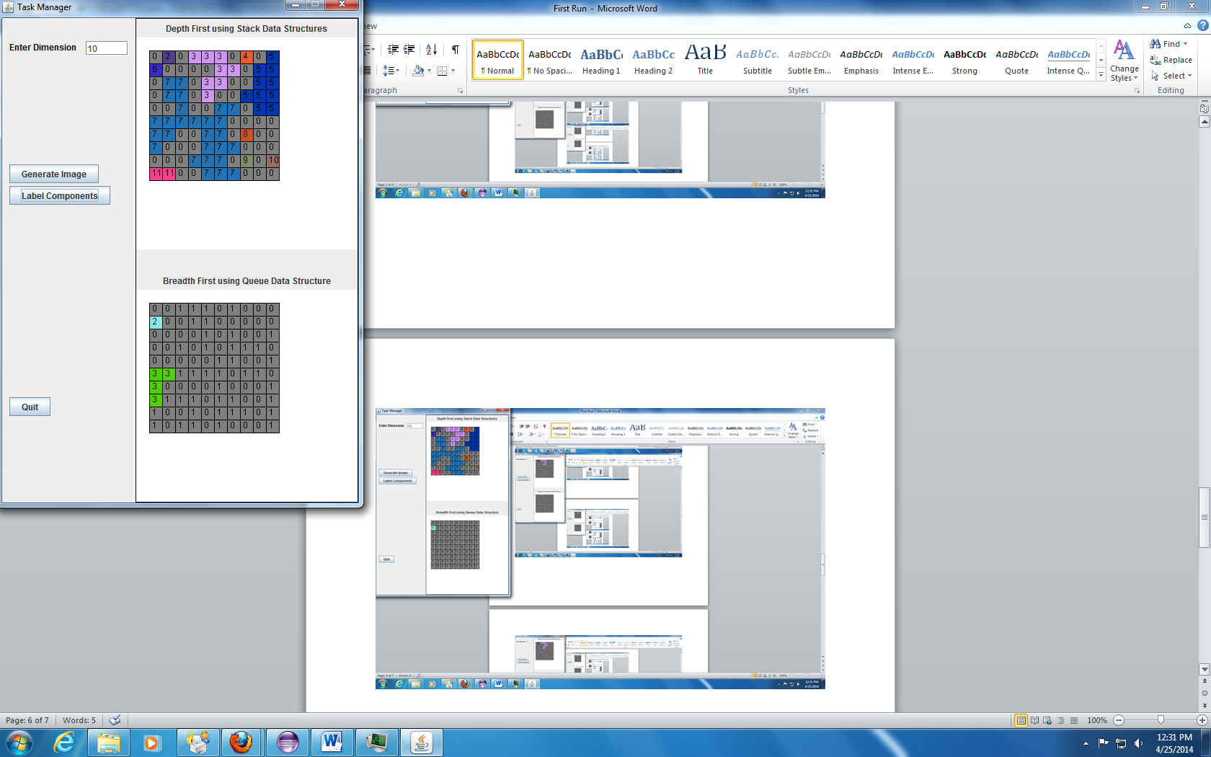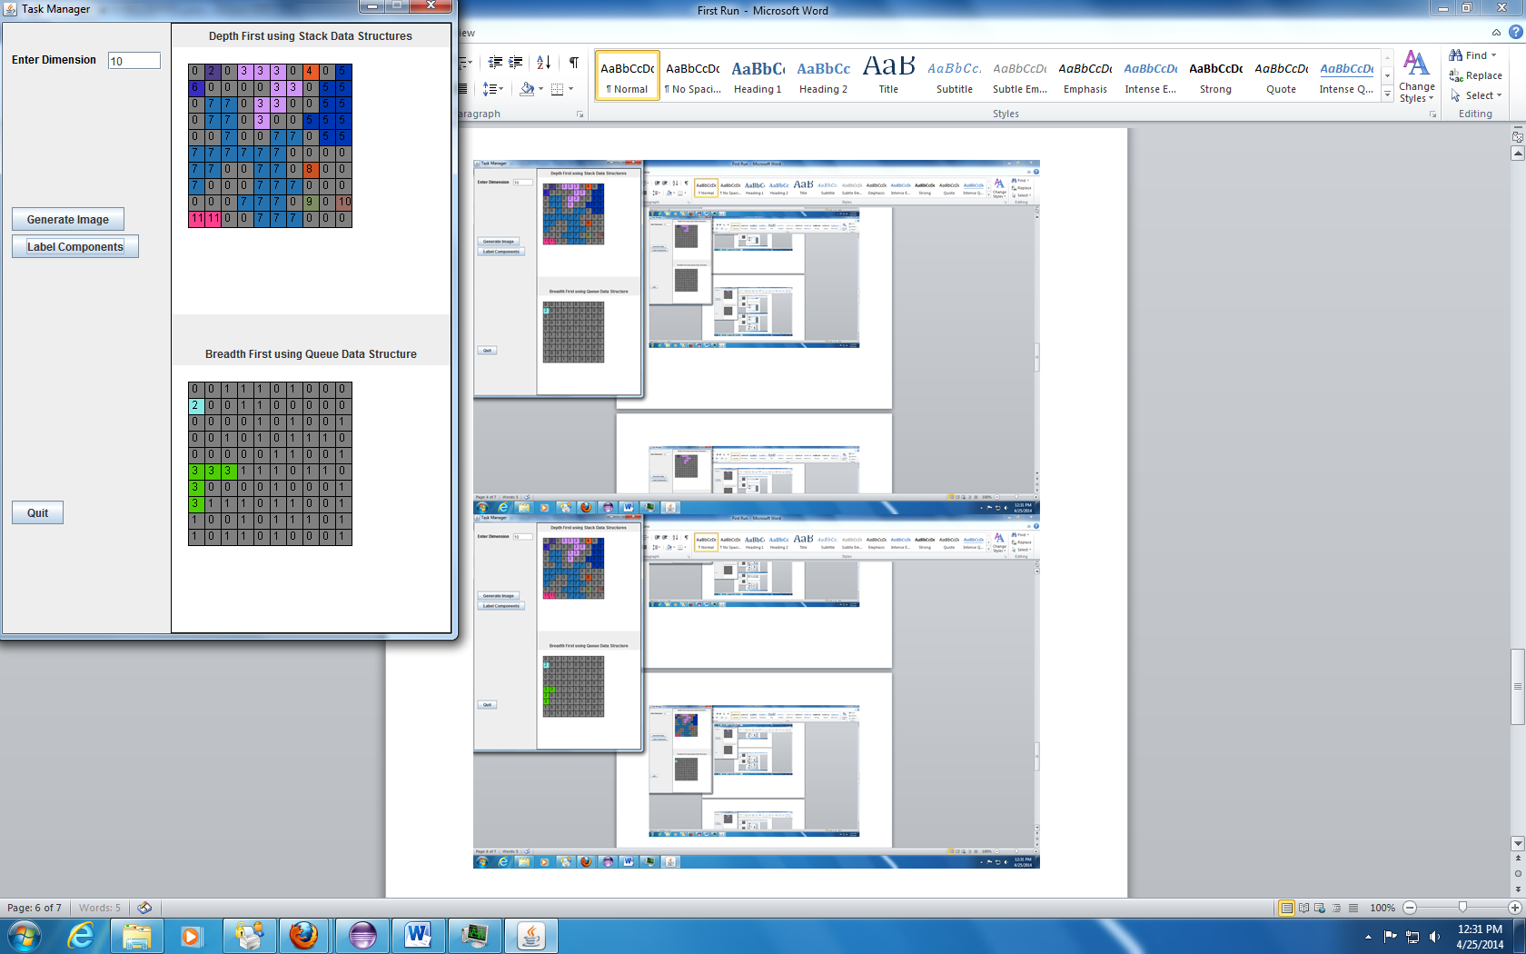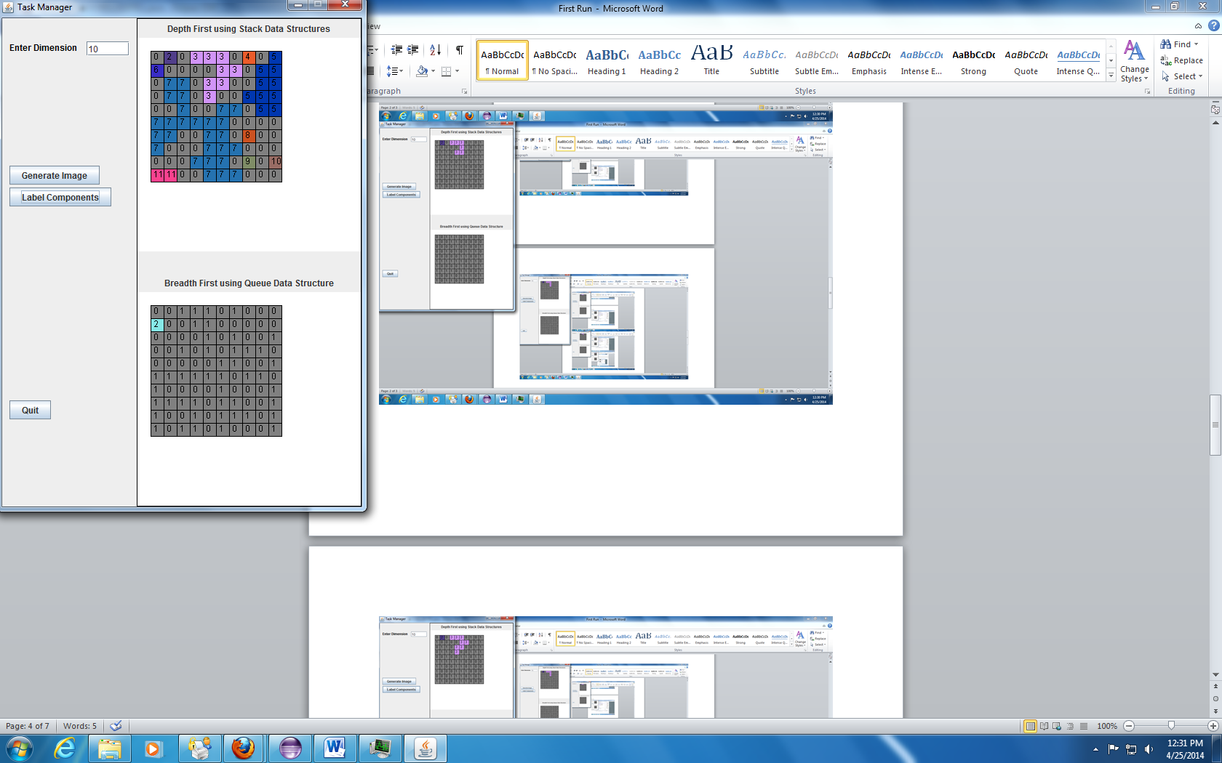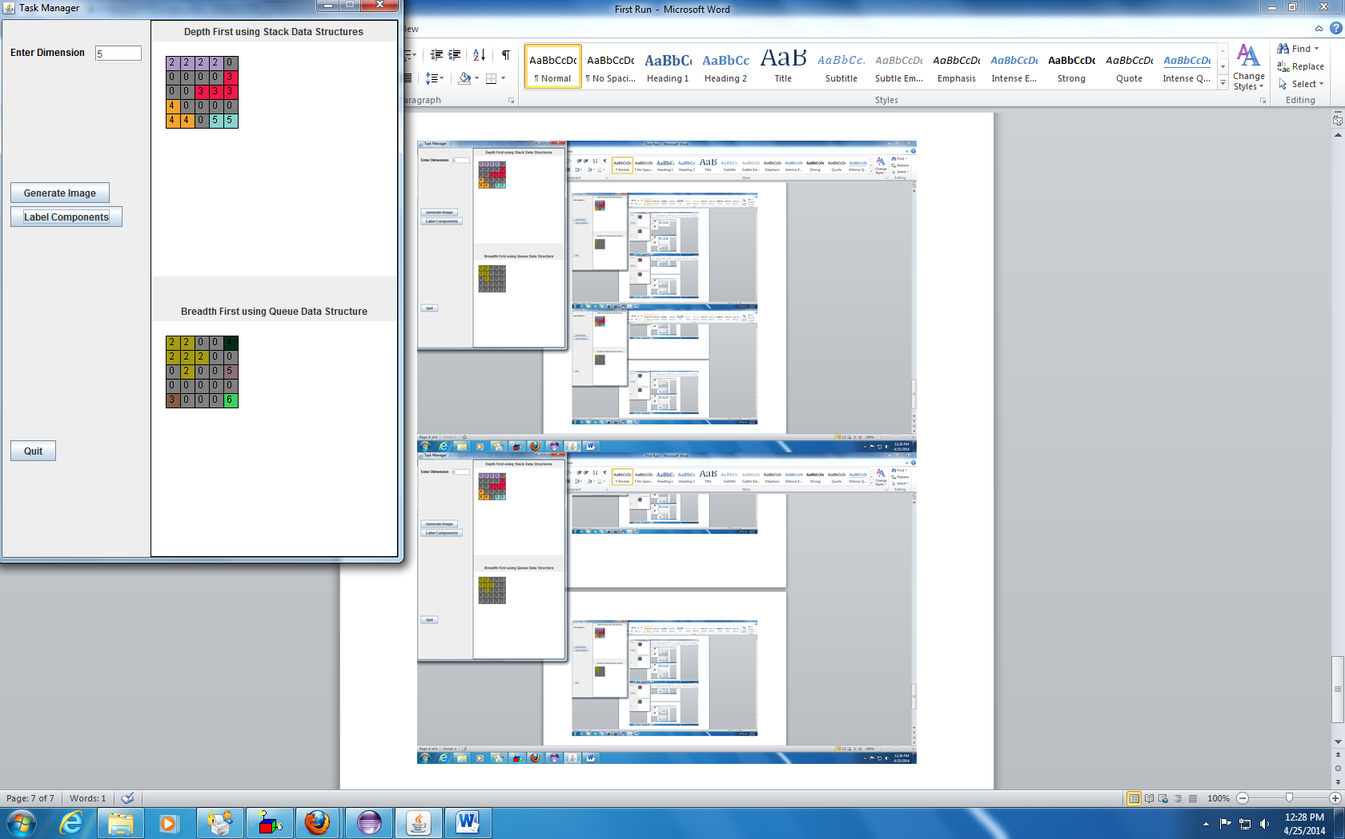5x5 (Prove that all the color is in random)

